Results

Summary of Key Results

The key significant statistical findings were that muscimol infusions during stage 2 of acquisition suppressed responding to cues A+ and AX- to similarly low levels, whereas the saline group acquired greater CRs to A+ than AX-. When tested drug-free during the summation test, both the muscimol and saline groups showed a significant reduction in responding to BX- relative to B-, an effect which did not differ in magnitude between groups. Similarly, during the retardation test both groups acquired greater responding to the novel cue Y+ than X+, a difference which did not differ in magnitude between groups. Taken together, these results suggest that while there was no significant evidence of cue X acting as an inhibitor in stage 2 in the muscimol group under drug infusions, both groups passed the summation and retardation tests of inhibition when subsequently tested drug-free.

An additional finding that was not expected was the effect of muscimol infusions on control cue Z. Specifically, muscimol infusions significantly reduced responding to Z+ during stage 2 of acquisition relative to the saline control group. The suppressed CRs to cue Z in the muscimol group persisted when trained further in stage 3 and during extinction in the retardation test when tested drug free. This suggests that the muscimol infusions impaired the acquisition of responding to this control cue.

Histology and Exclusions

Cannulae placements are depicted in Figure 9. A total of two animals were excluded from further analysis due to inaccurate cannulae placement. Specifically, bilateral cannulae tip placement was found within the dorsal part of the anterior olfactory nucleus, ventral to LO, in one muscimol animal, and one cannulae tip was cannula tip embedded within the white matter of the forceps minor of the corpus callosum in a saline group rat. During training two further animals from the saline group were excluded and were not trained further as they failed to acquire magazine training after several days or repeatedly failed to consume all rewards within a session. Final numbers for infusion groups in Experiment 1c were saline (*n* = 13) and muscimol (*n* = 15).

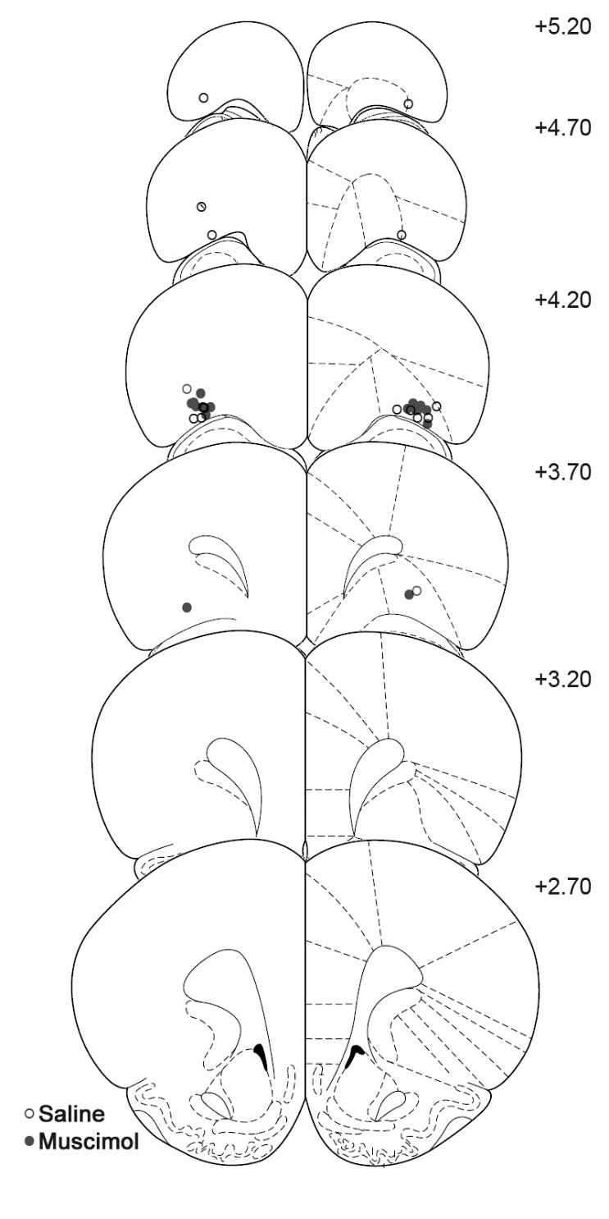

Figure 9. Schematic representation of cannulae tip placements in the orbitofrontal cortex from Experiment 1c. Coronal sections are identified in mm relative to bregma (Paxinos and Watson, 1997).

PreCS Rates

Rates of responding did not significantly differ between groups during any of the testing phases and justified the analysis of CS-PreCS difference scores as measures of discriminative responding to the cues in consequent analyses. Briefly, Group x Day mixed ANOVAs were run separately for each stage of testing. During stage 1 acquisition (main effect of Group *F*(1, 26) = 3.20, *p* = .09; Group x Day interaction *F*(3, 78) = 1.47, *p* = .23), stage 2 feature negative training, stage 3 cue re-training, summation and retardation tests all Group and Group x Day interactions did not reach significance (all *F* < 2.01, *p* > .16).

Stage 1 Acquisition (Days 1-4)

Acquisition of discriminative responding to each cue did not differ between groups, however cue Z (the flashing magazine light) elicited a much lower level of responding than cues A and B (Figure 10A). This impression was confirmed by a mixed ANOVA with main factors of Group (saline, muscimol), Cue (A, B, Z) and Day (1-4) revealing a significant Cue x Day interaction (*F*(6, 156) = 3.72, *p* = .002). Given that cue Z was not counterbalanced, and was located within the magazine, the nature of responding to this cue was fundamentally different to all other cues and was therefore analysed in separate Day x Cue x Group ANOVAs. Acquisition of responding to cues A and B increased significantly (main effect of day *F*(3, 78) = 20.41, *p* < .001; significant linear trend across Day *F*(1, 26) = 37.33, *p* < .001) and did not differ between groups (all other effects *F* < 1.5, *p* >.23). Responding to cue Z did not differ between groups, nor did it increase across Day (effect of Group, Day and Group x Day interaction, all *F* < 1.6, *p* > .21). However, discriminative responding to cue Z was significantly above PreCS levels (test of model intercept i.e. test of grand mean responding above 0, *F*(1, 26) = 24.17, *p* < .001). Therefore, at the end of stage 1, all animals had acquired discriminative responding to all cues, but responding was significantly lower to cue Z.



Figure 10. LO inactivation disrupts discriminative performance in Pavlovian conditioned inhibition. Rates of discriminative magazine responding presented as CS-preCS difference scores in 10s. **(A)** Acquisition to cues A+ and B+ during stage 1 did not differ between to-be infused groups. **(B)** Acquisition of the A+/AX- discrimination following saline or muscimol infusions. Following saline infusions, responding to A+ was greater than AX- whereas muscimol infusions abolished differences in responding to A+ and AX-. **(C)** Acquisitionin stage 3 in the absence of infusions revealed significantly lower responding to control cues B+. Error bars depict +SEM.

Stage 2 Feature negative training- Infusion (Days 5-10)

Acquisition of the feature negative discrimination, i.e. greater responding to A+ than AX-, appeared to be successful in the saline but not the muscimol group (Figure 10B). This impression was confirmed by a Group x Cue (A+, AX-) x Day (6 days) mixed ANOVA. The analysis revealed a significant 3-way Group x Cue x Day interaction (*F*(5, 130) = 2.89, *p* = .02; and a significant Group x Cue interaction *F*(1, 26) = 8.12, *p* = .008) suggesting that there were group differences in acquisition of the feature negative discrimination across days. Separate follow up Cue x Day ANOVAs were conducted for each group to explore this interaction. The muscimol group increased responding to the cues across days (main effect of Day, *F*(5, 70) = 4.88, *p* = .001; linear trend *F*(1, 14) = 11.66, *p* = .004) but did not discriminate between cues (non-significant effect of Cue and Cue x Day interaction, all *F*<1, *p* > .86). In contrast, the saline group acquired greater responding to A+ than AX- as suggested by a significant effects of Cue(*F*(1, 12) = 11.13, *p* = .006), Day (*F*(5, 60) = 7.84, *p* < .001), and a Cue x Day interaction (*F*(5, 60) = 5.95, *p* < .001). Specifically, in the saline group responding to A+ increased (linear trend *F*(1, 12) = 28.04, *p* < .001), whereas responding to AX- did not significantly increase across days increased (linear trend *F*(1, 12) = 2.68, *p* = .13). Therefore, the saline group showed behavioural evidence of inhibition the stage 2 feature negative discrimination whereas the muscimol group did not.

Stage 3 Cue Training (Days 11-12)

Re-acquisition to cue B (Figure 10C) was assessed with a Group x Day (11, 12) mixed ANOVA which revealed that responding to cues increased across days (main effect of Day, *F*(1, 26) = 22.37, *p* = .001). Furthermore, a main effect of Group *F*(1, 26) = 4.59, *p* = .04) and a Group x Day interaction (*F*(1, 26) = 4.23, *p* = .05) revealed group differences in responding to cue B. Simple effects revealed that the muscimol group responded significantly lower than the saline group on day 11 (*F*(1, 26) = 7.52, *p* = .01) but not day 12 (*F*(1, 26) = 1.86, *p* = .19). This suggests that the effect of muscimol infusion in stage 2 temporarily lowered overall performance when trained drug free in stage 3.

Stage 4 Summation probe test (Day 13)

The results of the summation test (Figure 11A) suggested that both groups responded less to BX- than B- which suggests that cue X is inhibiting performance. This observation was confirmed by a Group x Cue (B-, BX-) mixed ANOVA. Specifically, there was a significant main effect of Cue (*F*(1, 26) = 7.60, *p* = .01). While the magnitude of the Cue effect may appear weaker in the muscimol group than the saline group, this observation was not supported statistically (no main effect of Group *F*(1, 26) = 0.72, *p* = .40, or Group x Cue interaction *F*(1, 26) = 2.12, *p* = .16). These findings support the acquisition of conditioned inhibition to cue X as assessed by a summation test.



Figure 11. LO inactivation does not block the acquisition of Pavlovian conditioned inhibition. **(A)** A summation test revealed lower responding to BX- than B- in both the saline and muscimol groups. **(B)** A retardation test revealed significantly lower responding to X+ than to the novel control cue Y+ in both the saline and muscimol groups. Rates of discriminative magazine responding are presented as CS-preCS difference scores in 10s. Error bars depict +SEM.

During the summation test, responding to the rewarded cues B+ (presented at the start of the test) and Z+ (intermixed throughout the test session) did not significantly differ between groups. A Group x Cue (B+, Z+) mixed ANOVA supported this with no significant effects of Cue (*F*(1, 26) = 0.14, *p* = .71), Cue x Group (*F*(1, 26) = 0.26, *p* = .62) or Group (*F*(1, 26) = 3.58, *p* = .07).

Stage 5 Retardation test (Days 14-16)

Acquisition to target cue X+ appeared significantly lower than control cue Y+ in both groups (Figure 11B). A Group x Cue (X+, Y+) x Day (14, 15, 16) mixed ANOVA revealed a significant main effect of Cue (*F*(1, 26) = 8.82, *p* = .006) and Day (*F*(2, 52) = 5.53, *p* = .008) but no other significant effects (Cue x Day interaction *F*(2, 52) = 2.22, *p* = .12, all other *F*< 1.42, *p* > .24). This retarded acquisition to cue X+ relative to Y+ suggests a significant retardation effect of similar magnitude in both the saline and muscimol groups.

Cue Z

Stage 1 Acquisition (Days 1-4)

Responding to cue Z did not differ between groups (Figure 12), nor did it increase across Day (effect of Group, Day and Group x Day interaction, all (all *F* < 1.6, *p* > .21). However, discriminative responding to cue Z was significantly above PreCS levels (test of model intercept i.e. test of grand mean responding above 0, *F*(1, 26) = 24.17, *p* < .001). Therefore, at the end of stage 1, all animals had acquired discriminative responding to all cues, but responding was significantly lower to cue Z.

Stage 2 Feature negative training- Infusion (Days 5-10)

The increase in responding to Z+ across stage 2 was greater in the saline group than the muscimol group (Figure 12). This impression was confirmed by a significant main effect of Group (*F*(1, 26) = 16.46, *p* < .001) and a Group x Day interaction (*F*(5, 130) = 3.47, *p* = .006; Group x Day linear trend contrast *F*(1, 26) = 6.27, *p* = .02). Follow up linear trend contrasts across Day revealed significant increases in responding in the saline group (*F*(1, 12) = 18.97, *p* = .001) but not the muscimol group (*F*(1, 14) = 3.26, *p* = .09; muscimol group responding remained significantly above baseline *F*(1, 14) = 22.37, *p* < .001). Therefore, the saline group acquired responding to Z+ across the infusion period whereas the muscimol group did not, but did discriminatively respond above baseline.

Stage 3 Cue Training (Days 11-12)

Drug-free acquisition to cue Z (Figure 12) was assessed with a Group x Day (11, 12) mixed ANOVA which revealed that responding to cues increased across days (main effect of Day, *F*(1, 26) = 4.24, *p* = .05). Furthermore, a significant main effect of Group *F*(1, 26) = 7.17, *p* = .01) but no significant Group x Day interaction (*F*(1, 26) = 0.31, *p* = .58) revealed that responding to cue Z was greater in the saline than the muscimol group.

Retardation test (Days 14-16): Extinction

Extinction to cue Z in across the retardation test revealed significantly lower responding to in the muscimol group (Figure 12). A Group x Day mixed ANOVA supported this interpretation with a significant main effect of Group (*F*(1, 26) = 4.50, *p* = .04) and Day(*F*(2, 52) = 27.44, *p* < .001) but no Group x Day interaction (*F*(2, 52) = 1.80, *p* = .18).



Figure 12. LO inactivation reduced responding to control cue Z+. Responding during stage 1, under drug infusion in stage 2, and drug free in further acquisition during stage 3 and extinction during the retardation test. The muscimol group responded significantly lower than the saline group in stage 2 and this difference persisted when tested drug free in stage 3 and during extinction in the retardation test. Rates of discriminative magazine responding are presented as CS-preCS difference scores in 10s. Error bars depict +SEM.

Consumption test (Days 17-18)

Prior to the consumption test 2 saline and 1 muscimol infused animal lost their cannula assembly and were not eligible for testing (saline *n* = 11, muscimol *n* = 14). All animals consumed all pellets delivered by the end of the session on both days, regardless of infusion group. Similarly, there was no evidence that muscimol infusion differentially affected magazine approach for reward (Figure 13). A Group x Infusion (No Infusion, Infusion) x Block (6 blocks of 5 mins) mixed ANOVA found no significant main effect or interactions with Group (all *F*< 1.00, *p* > .34). A main effect of Block (*F*(5, 115) = 246.18, *p* < .001), Infusion (*F*(1, 23) = 6.53, *p* = .02), and Block x Infusion interaction (*F*(5, 115) = 2.69, *p* = .02), revealed that responding was lower on infusion day 18. This pattern of results suggests that responding was higher on no infusion day 17 than infusion day 18, but these differences were not affected by the drug infused prior to the session. These findings suggest that the low responding to all cues in stage 2 following muscimol infusions is unlikely to be due to suppressed appetite or motivation for the US.



Figure 13. LO inactivation does not affect consumption behaviour. Magazine entry behaviour to consume free reward in 30 mins following no drug infusion on day 17 (left panel) and an infusion of muscimol or saline into LO on day 18 (right panel). Magazine approach and consumption of reward was not affected by LO inactivation. Rates of magazine approach within each 5 minute block of the session are presented. Error bars depict +SEM.

Summary of Key Results

The key significant statistical findings were that muscimol infusions during stage 2 impaired the between-session retention of behavioural extinction to cues AX- and C- relative to saline infusions. In contrast, within-session behavioural extinction was not impaired in the muscimol group relative to the saline group during stage 2, and if anything within-session extinction was more rapid in the muscimol group. In addition to these group differences during stage 2, both groups extinguished more rapidly to cue AX- than to C- across days. This suggests that both groups discriminated between AX- and C- during stage 2. Following stage 2, when tested drug free the muscimol group showed greater responding (i.e. impaired extinction) to both cues A- and C- relative to the saline group.

Both groups showed significantly reduced responding to BX- than B- during the summation test. However, during the retardation test the muscimol group showed a small but significantly enhanced rate of acquisition to the novel cue Y+ relative to X+ (i.e. a retardation effect) whereas there were no significant differences in responding to these cues in the saline group. This suggests that both groups passed the summation test of inhibition but only the muscimol group passed the retardation test of inhibition as well.

Histology and Exclusions

Cannulae placements are depicted in Figure 14. All cannulae tips were located within LO or DLO. Final group numbers were saline (*n* = 12) and muscimol (*n* = 12).

PreCS Rates

Rates of responding did not significantly differ between groups during any of the testing phases and justified the analysis of CS-PreCS difference scores as measures of discriminative responding to the cues in consequent analyses. Briefly, one-way Group or Group x Day mixed ANOVAs were run separately for each stage of testing to assess the effects of Group. During stage 2 feature negative training (main effect of Group *F*(1, 22) = 2.55, *p* = .12; Group x Day interaction *F*(3, 66) = 1.72, *p* = .17), stage 3 testing (Group *F*(1, 22) = 3.32, *p* = .08), during stage 1 acquisition, summation and retardation tests all Group and Group x Day interactions failed to reach significance (all *F* < 1.72, *p* > .17).

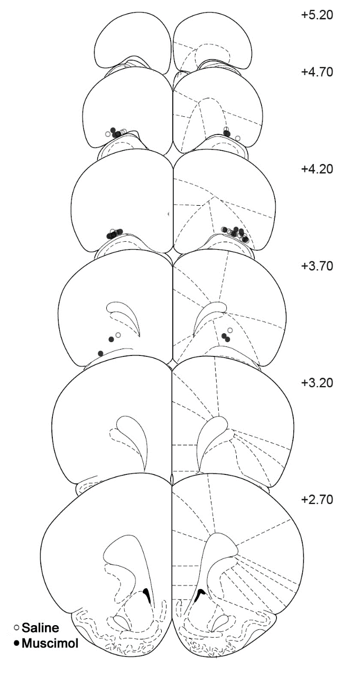

Figure 14. Schematic representation of cannulae tip placements in the orbitofrontal cortex from Experiment 1d. Coronal sections are identified in mm relative to bregma (Paxinos and Watson, 1997).

Stage 1 Acquisition (Days 1-9)

Acquisition of discriminative responding to cues A, B, C and Z did not differ between (infusion) groups across stage 1 of acquisition (Figure 15A). As in Experiment 1c, cue Z was analysed separately. A Group x Cue (A, B. C) x Day mixed ANOVA revealed a significant main effect of Day (*F*(8, 176) = 26.07, *p* < .001) but no significant effects of Cue, Group or their interactions (all *F* < 1, *p* > .65). Similarly a Group x Day ANOVA found significant acquisition to cue Z (main effect of Day *F*(8, 176) = 8.80, *p* < .001) but no effects of Group (all *F* < 1, *p* > .99). Therefore, acquisition was successful to all cues and did not differ between groups. 

Figure 15. LO inactivation disrupts between- but not within-session extinction (a replication). Rates of discriminative magazine responding presented as CS-preCS difference scores in 10s. **(A)** Acquisition to cues A+, B+ C+ during stage 1 did not differ between to-be infused groups. Responding prior to cannulation depicted left of the dashed line and post-surgical performance depicted to the right of the dashed line. **(B)** Extinction of AX- and C- during stage 2 of the conditioned inhibition procedure depicted in blocks of 6 trials within each session. Following saline infusions, responding to AX- and C- declined within- and between-sessions whereas muscimol infusions into LO impaired the retention of extinction between-session extinction. **(C)** Test of the responding to A- and C- drug-free depicted in blocks of 6 trials within the session. Responding in the muscimol group was significantly higher than the saline group but responding did not differ between cues. Error bars depict +SEM.

Stage 2 Feature negative training - Infusion (Days 10-13)

Responding to AX- and C- under drug infusion appeared to differ between groups (Figure 15B) such that behaviour in the muscimol group appeared to extinguish more rapidly within-session but not between sessions compared to the saline group. A mixed Group x Cue (AX-, C-) x Day (4) x Block (3 blocks of 6 trials) ANOVA supported the observed pattern of results. In all animals, extinction between and within-sessions was supported by significant main effects of Day (*F*(3, 66) = 17.65, *p* < .001) and Block (*F*(2, 44) = 24.40, *p* < .001) and a Day x Block (*F*(6, 132) = 2.52, *p* = .02) interaction. Overall responding to both cues did not differ (non-significant main effect of Cue *F*(1, 22) = 1.69, *p* = .21) but a significant Cue x Day interaction suggested that extinction between days was more rapid for AX- than C- (an effect that did not differ between groups, non-significant Group x Cue x Day interaction *F*(3, 66) = 0.83, *p* = .48). Follow up analysis of cue differences revealed a significant Cue x Day linear trend interaction *F*(1, 22) = 8.41, *p* = .01, such that the magnitude of significant negative trend across days was greater for C- (*F*(1, 22) = 33.17, *p* < .001) than AX- (*F*(1, 22) = 7.77, *p* = .01).

While there was no overall effect of Group (*F*(1, 22) = 0.63, *p* = .44) there was a significant Group x Day (*F*(3, 66) = 2.93, *p* = .04) and a Group x Block interaction (*F*(2, 44) = 16.35, *p* < .001; all other interactions with Group failed to reach significance, all *F* < 2.30, *p* > .11). Follow up analysis of linear and quadratic Group x Day trend interactions failed to reach significance (linear *F*(1, 22) = 3.44, *p* = .08, quadratic *F*(1, 22) = 3.05, *p* = .10). This suggests that the impaired between session extinction observed in the muscimol group only approached significance in Experiment 1d. Follow up analysis of linear and quadratic Group x Block trend interactions were significant (linear *F*(1, 22) = 34.64, *p* = .001; quadratic *F*(1, 22) = 20.94, *p* < .001). Simple trend contrasts across Block revealed significant linear and quadratic trend for the muscimol group (linear *F*(1, 11) = 14.69, *p* = .003, quadratic *F*(1, 11) = 5.08, *p* = .046) but only significant linear trend in the saline group (linear *F*(1, 11) = 21.73, *p* = .001, quadratic *F*(1, 11) = 01, *p* = .93). This pattern of results suggests that the linear decrease in within-session extinction was greater in the muscimol group compared to the saline group. This greater linear increase in the muscimol group is likely to be due to higher responding at the start of each session in the muscimol group, whereas the lower responding in the saline group at the start of each session provided less opportunity for further decrease in responding.

Given the failure to find the source of the significant Group x Day interaction described above a Group x Cue x Day analysis was run on the first block of trials only. This analysis will allow for a more direct assessment of impairments in the retention of between-session extinction. This analysis revealed a significant main effect of Day (*F*(3, 66) = 10.19, *p* < .001), a Cue x Day interaction Day (*F*(3, 66) = 2.88, *p* = .04) and a significant main effect of Group (*F*(1, 22) = 4.46, *p* < .05). This suggests that there was evidence of between-session extinction in both the saline and the muscimol groups, however overall responding was higher in the muscimol group. Therefore, there is some evidence of poorer between-session extinction retention in the muscimol group compared to the saline group.

Stage 3 Extinction test (Day 14)

Drug free tests of A- and C- revealed that the muscimol group did not acquire extinction to both cues to the same extent as the saline group (Figure 15C). Also, there was no evidence that compound extinction of cue A with cue X had “protected” cue A from extinction relative to cue C, in fact the mean responding to both cues were identical in both groups. A mixed Group x Cue (A-, C-) x Block (4 blocks of 3 trials) ANOVA supported this observation with no significant effect of Cue or Group x Cue interaction (both *F*(1, 22) = 0.00, *p* = 1.00 as a result of identical mean responses). However, there was a significant evidence of Block (*F*(3, 66) = 3.45, *p* = .02) suggesting within-session extinction behaviour at test and a significant main effect of Group (*F*(1, 22) = 16.02, *p* = .001) showing higher responding in the muscimol than the saline group (all other effects did not reach significance, all *F* < 1.38, *p* > .26).

Stage 4 Summation test (Day 15)

Responding to cue B was decreased by the compound BX to similar levels in both groups at test (Figure 16A). A Group x Cue (B-, BX-) mixed ANOVA supported this with a significant main effect of Cue (*F*(1, 22) = 4.67, *p* = .04) but no significant effect of Group (*F*(1, 22) <.01, *p* = .96) or Group x Cue interaction (*F*(1, 22) = 0.10, *p* = .75). Therefore, the summation test provided evidence of conditioned inhibition to cue X in both groups.

During the summation test, responding to the rewarded cues B+ (presented at the start of the test) and Z+ (intermixed throughout the test session) did not significantly differ between groups. A Group x Cue (B+, Z+) mixed ANOVA supported this with no significant effects of Cue (*F*(1, 22) = 1.86, *p* = .18), Cue x Group (*F*(1, 22) = 1.12, *p* = .30) or Group (*F*(1, 22) = 0.29, *p* = .60).



Figure 16. LO inactivation does not block the acquisition of Pavlovian conditioned inhibition (a replication). **(A)** A summation test revealed lower responding to BX- than B- in both the saline and muscimol groups. **(B)** A retardation test revealed significantly lower responding to X+ than to the novel control cue Y+ in muscimol group but not the saline group. Rates of discriminative magazine responding are presented as CS-preCS difference scores in 10s. Error bars depict +SEM.

Stage 5 Retardation test (Days 16-18)

Responding during the retardation test suggested that the rate of acquisition to cue Y was greater than cue X in the muscimol group but not the saline group (Figure 16B). However, this observation was supported statistically by a Group x Cue (X, Y) x Day mixed ANOVA which failed to reveal a significant Group x Cue x Day 3-way interaction (*F*(2, 44) = 2.23, *p* = .12; there was a significant main effect of Day *F*(2, 44) = 10.87, *p* < .001, but all other effects failed to reach significance, all *F* < 2.68, *p* > .12). Given the weak evidence for conditioned inhibition in this experimental design in the literature, planned orthogonal linear and quadratic Group x Cue x Day trend contrasts were tested. This planned analysis revealed a significant quadratic (*F*(1, 22) = 5.42, *p* = .03) but not linear (*F*(1, 22) = 0.68, *p* = .42) 3-way interaction. Follow up Cue x Day quadratic trend was found to be significant in the muscimol group (*F*(1, 11) = 7.53, *p* = .02) but not the saline group (*F*(1, 11) = 0.14, *p* = .71). This suggested that the rate of increase during acquisition was greater for cue Y than cue X in the muscimol but not the saline group.

Cue Z

Responding to control cue Z did not differ throughout training (Figure 17). For completeness, responding during acquisition to cue Z did not differ between groups in stage 1. A mixed Group x Day(1-9) ANOVA supported this observation revealing only a main effect of day (*F*(8, 176) = 8.80, *p* < .001) but no main effect of Group or Group x Day interaction (all *F* < 0.18, *p* > .99). The rate of extinction to control cue Z during the retardation test did not differ between groups as confirmed by a mixed Group x Day(16, 17, 18) ANOVA with no significant effect of Group (*F*(1, 22) = 2.07, *p* = .16) or Group x Day interaction (*F*(2, 44) = 0.08, *p* > .93; significant main effect of Day *F*(2, 44) = 20.78, *p* < .001).



Figure 17. Responding to control cue Z does not differ between groups in Experiment 1d. The rate of acquisition to cue Z in stage 1 (left panel) and the rate of extinction to cue Z during the retardation test did not differ between groups. Rates of discriminative magazine responding are presented as CS-preCS difference scores in 10s. Error bars depict +SEM.

Locomotor activity

There was no differential effect of drug infusion on general locomotor activity (Figure 14D). This was supported by a mixed Group x Block (6 blocks of 10 mins) on total ambulatory distance which revealed a significant effect of Block (*F*(5, 110) = 93.52, *p* < .001) but no Group or Group x Block interaction effects (all *F* < 1, *p* > .96).



Figure 18. LO inactivation does not affect locomotor activity in Experiment 1d. Locomotor activity represented by the ambulatory distance travelled per 5 mins is presented in blocks of 5 mins within-session. Activity did not differ between the saline and muscimol groups. Error bars depict +SEM.